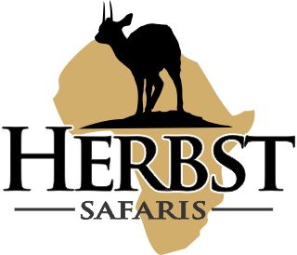
HERBST SAFARIS (Pty) Ltd Reg No. 2017/229809/07
Farm Dansfontein P.O. Box 5, Tolwe, 0690 Riaan +27 82 467 2912
Karin +27 79 895 3403
Fax: +27 86 778 5121
E-mail: bookings@herbstsafaris.co.za Website: www.herbstsafaris.co.za

TIPS and GRATUITIES

Tips or Gratuities has always been a questionable question. Everybody understands that this is not a must but rather a way of saying thank you.

Over many years of hunting we have found the following to be the general averages. It is how ever your own prerogative to decide if and what you want to give. The following could be used as guidelines on TIPPING of staff:

Professional Hunter - $ 50 to $ 100 per day
Tracker - $ 15 per day (One tracker per client)
Skinning shed and Skinners - $ 15 per day
Camp Staff - $ 50 per day

If you decide that you will tip the staff we prefer that you do it yourself ( we can also assist with the tipping ) to each individual or group of individuals (Camp Staff). Please also make sure that you do have enough cash with you to do that. We will at the end of the Safari provide you with an full list of all the people that has been of assistance to you during your safari.

Regards
Riaan Herbst

