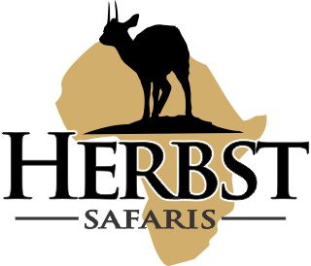
HERBST SAFARIS (Pty) Ltd Reg No. 2017/229809/07
Farm Dansfontein P.O. Box 5, Tolwe, 0690 Riaan +27 82 467 2912
Karin +27 79 895 3403
Fax: +27 86 778 5121
E-mail: bookings@herbstsafaris.co.za Website: www.herbstsafaris.co.za

Dear Client

Thank you again for booking with Herbst Safaris.
Included is information which is very much needed for your safari preparation and travels to South Africa.

RIFLE PERMITS
To import your rifles into South Africa you need to apply to a couple rules and regulations. The Professional Hunters Association of South Africa (WWW.Professionalhunters.co.za) offers a service to clients on this regard. You can contact them at reception@phasa.co.za to get this process going. Just mention that you will be hunting with Herbst Safaris to allow them to get all the correct paperwork together. Most of our clients make use of Afton house for rifle import permits. You can contact them at aftongh@netactive.co.za or +27 11 391 7625

CITES PERMIT
If you are going to hunt CITES animals make sure that you are bringing an original CITES import permit with from your fish and wildlife. This is valid for 12 months and could be extended.

PERSONAL INFORMATION
We will send you a Herbst Safaris Client Info Sheet, which we need you to complete and send back. This document you will receive once you have booked and paid a deposit for your safari. You will also receive and Herbst Safaris Contract and a Herbst Safaris Essentials List

TIPS and GRATUITIES
Over many years of hunting we have found the following to be the general averages. It is how ever your own discretion to decide if and what you want to give. The following could be used as guidelines on TIPPING of staff:
Professional Hunter - $ 50 to $ 100 per day
Tracker - $ 15 per day
Skinners - $ 15 per day
Camp Staff - $ 50 per day (Chef, waiters, cleaners and camp managers)

TAXIDERMY
Several options are available and depending on your needs we can advise you on sending the raw materials back home or have it mounted in Africa.

Enjoy your Safari Preparation

